**Software Requirements Specification**

**for**

**Disease and severity detection**

**of crop and prediction of pesticides**

**Version 1.0**

**Prepared by:**

**Anuj Jain (BE/25036/14)**

**Yash Tongia (BE/25030/14)**

**Supervised by:**

**Dr. Madhavi Sinha**

**Birla Institute of Technology, Mesra, Jaipur Campus**

**October 5,2017**

**Table of Contents**

**Table of Contents………………………………………………………………………………...2**

**Revision History………………………………………………………………………………….2**

**1.** **Introduction…………………………………………………………………………………..3**

1.1 Purpose………………………………………………………………………………………….3

1.2 Intended Audience and Reading Suggestions…………………………………………………..3

1.3 Scope of a project...……………………………………………………………………………..3

**2.** **Overall Description………………………………………………………………………….4**

2.1 Product Perspective……………………………………………………………………………..4

2.2 Product Functions……………………………………………………………………………….4

2.3 Operating Environment………………………………………………………………………....5

2.4 Design and Implementation Constraints………………………………………………………..5

2.5 Assumptions and Dependencies………………………………………………………………...5

**3.** **System Interaction...…………….…………………………………………………………...5**

3.1 Use Case Diagram..……………………………………………………………………………..6

3.2 Hardware Interfaces……………………………………………………………………………..6

3.3 Software Interfaces……………………………………………………………………………...7

3.4 Communications Interfaces……………………………………………………………………..7

**4.** **Functional Requirements…………………………………………………………………....7**

4.1 User Interface…………………...……………………………………………………………....7

4.2 System Interface………………………………………………………………………………...7

4.3 Sentiment Analysis……………………………………………………………………………...8

**5.** **Other Nonfunctional Requirements………………………………………………………...8**

5.1 Performance……………………………………………………………………………………..8

5.2 Availability……………………………………………………………………………………...8

5.3 Security………………………………………………………………………………………….8

5.4 Maintainability…………………………………………………………………………………..8

5.5 Scalability……………………………………………………………………………………….8

**6. References…………………………………………………………………………………….8**

**Revision History**

|  |  |  |  |
| --- | --- | --- | --- |
| **Name** | **Date** | **Reason for changes** | **Version** |
|  |  |  |  |
|  |  |  |  |

# 

# **1.Introduction**

## **1.1 Purpose**

The purpose of this Software Requirements Specification (SRS) for the ‘Disease and severity detection of crop and prediction of pesticides’ is to convey information about the application's requirements, both functional and non-functional, to the reader.  
This document provides:  
• A description of the environment in which the application is expected to operate.  
• A definition of the application's capabilities.  
• A specification of the application's functional and non-functional requirements.  
The document is intended to serve several groups of audiences:  
• First, it is anticipated that the SRS will be used by the application designers. Designers will use  
the information recorded here as the basis for creating the application's design.  
• Second, the client for the project is expected to review this document. The SRS will serve to establish a basis for agreement between the client and development team about the functionality to be provided by the application.  
• Third, the application maintainers will review the document to clarity their understanding of  
what the application does.

## **1.2 Intended Audience and Reading Suggestions**

The intended audience is anyone who is interested in implementing and knowing more

about disease and severity detection of crop and prediction of pesticides like farmers and agriculturist. Also, thedocument will be utilized to evaluate the model’s design and features.

## **1.3 Scope of a Project**

The disease detection model in plants will help users to identify disease present in plant and will suggest the user amount and the type of fertilizer a user must add to cope up with the disease present in a particular type of plant.

Given a large set of data set, disease detection in plants is done by comparing different information of plant with that of given plant in data set, disease is detected on the basis amount and type of difference between data set values and actual values**.**

The disease and severity detection of crop and prediction of pesticides will use various algorithms to various type of suggestion about crop condition. It:

* Provide access to a very large information collection
* Provide User-friendly interface
* Supports Advance Search Features
* Suggests amount and type of fertilizers to be added in the crop.

The Interface has to be simple to use, as the target end-users for the system are

non-technical persons.

This system aims to automate the disease and severity detection of crop and prediction of pesticides.

# **2. Overall Description**

## **2.1 Product Perspective**

Disease detection in plants is an important way to gauge the information about productivity of crop. A collection of

movie reviews is what gives us a deeper qualitative insight on different aspects of the movie.

A textual movie review tells us about the strong and weak points of the movie and deeper

analysis of a movie review can tell us if the movie in general meets the expectations of the

reviewer. Sentiment Analysis is a major subject in machine learning which aims to extract

subjective information from the textual reviews. The field of sentiment of analysis is closely

tied to natural language processing and text mining. We aim to utilize the relationships of the

words in the review to predict the overall polarity of the review. This model aims to use

sentiment analysis and recommend movies according to user perspective and other filters.

**2.2 Product Functions**

The main feature of the model is to recommend the movies based on its aesthetic features.

Data will be collected by web crawling different movie reviews sites and performing

sentiment analysis on this dataset using various machine learning techniques. The sentiment

analysis of the movie reviews is then required for the recommendation of the movies to the

user. Also the result of various techniques of sentiment analysis would be then compared to

evaluate the efficiency of the different techniques used, which provide better result.

Data flow diagram of recommendation system.

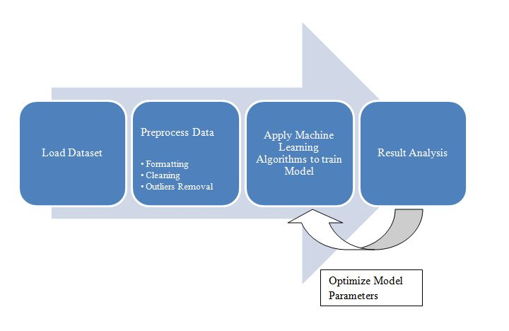

## **2.3 Operating Environment**

The model would operate on Windows 32 bit and 64 bit machines.It would also be able to

operate on Linux OS.

## **2.4 Design and Implementation Constraints**

In this project we will be using the weka library of java for machine learning techniques and

Html CSS for the design and development purposes. For web crawling, we consider many

websites as rottentomatoes, IMDb, TimesofIndia, etc

## **2.5 Assumptions and Dependencies**

The model will only recommend released movies as this sytem is working on reviews.

User should have basic knowledge to use internet and computer.

# **3. System Interaction**

## **3.1 Use Case Diagram**

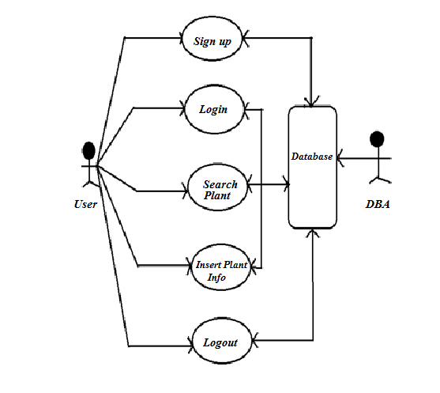

* Register - New user will register by providing the details and the details will be stored in database.
* Login - The user will login using username and password and the login data will be verified from the database.
* Search Plant- The user can search plant of their choice for which they want information from database.
* Insert Plant Information – The user should give information about the crop in the form of text or image.

## **3.2 Hardware Interfaces**

* 32/64-bit machine.
* A RAM size of 2GB and above.
* Hard disk capacity of 20GB and above.
* Processor Intel i3(min).

**3.3 Software Interfaces**

* Windows or Linux
* Matlab/Python
* MySQL

## **3.4 Communications Interfaces**

No communication interfaces will be required for this model.

# **4. Functional Requirements**

## **4.1 User Interface**

User can use the system by logging into it using username and password for existing user

and by registering if new user by providing required personal details.

User can search directly for the plant which he or she wants to get information about. After user need to provide information about the plant he or she has selected in terms of text or image(preferable).

**4.2 System Interface**

The system will provide user name and id and also maintain user session logs.

For a new user, the system will display images of diseased and healthy leaves of some crops user may select the crop type from the given images. For existing user, the system will display crops previously searched or as detailed in the sign-up form.

There will also be a logout button to redirect back to the login/signup page.

## **4.3 Disease Detection**

Disease detection of plant will take place based on information provided by the user and information present in the database by making comparison between the two-information based on several algorithms. These information about the plant in the database will be gained using dataset from different websites.

# **5. Other Nonfunctional Requirements**

## **5.1 Performance**

The system should return correct result with very less percentage from displaying other

Data. Also, the web crawling should be done properly to extract all possible information about a given crop.

## **5.2 Availability**

For the system to be available to users all the time, online server is must which provide 24

hour service daily.

## **5.3 Security**

The password of all the users should be stored properly and not exposed to anyone.

## **5.4 Maintainability**

The code will be well documented. Particular care will be taken to design the software

modularly to ensure that maintenance is easy.

## **5.5 Scalability**

The system will detect the presence of disease in the crop, with the type of disease that exists and if so will also recommend type and amount of pesticides to be used to make crop disease free.

## **6. References**

[1] data set - <http://www.cs.cornell.edu/people/pabo/movie-review-data/>

[2] [https://streamhacker.com/2010/05/10/text-classification-sentiment-analysisnaive-bayes- classifier/](https://streamhacker.com/2010/05/10/text-classification-sentiment-analysisnaive-bayes-%20classifier/)

[3]Vik Paruchuri(2015) Using Naïve Bayes to Predict Movie Review Sentiment. Retrieved  
from <http://blogdataquestion/blog/naive-bayes-movies/>

[4] Sentiment Analysis – Wikipedia – <https://en.wikipedia.org/wiki/Sentiment_analysis>